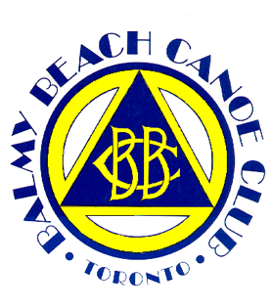
Welcome Campers!

On behalf of our entire team, we are incredibly excited to present a fun, unique, and active experience for your camper. Our goal is to make sure your camper is active all day long while enjoying themselves, building new friendships and learning various skills such as leadership and cooperation. The following are important things to know before your camper’s arrival.

If your child has an epi-pen or inhaler it is required that they carry it on them at all times, preferably in a fanny pack or their pocket. The only exception will be when the camp goes swimming at which time the medications will be with their assigned counselor. If your child has any other medical concerns that were not outlined in the registration, please let us know via email at sportscamp@balmybeachcanoeclub.com.

Campers are required to be signed in and out by an approved guardian each day. If you did not fill out the section of registration for approved guardians, please send us an email listing approved guardians for your child. The guardians must be aged 14 or older and bring a piece of ID at pick-up time. Please note that if someone who is not on the approved list comes to pick up your camper, they will not be allowed to sign the camper out. In this situation, please call or email ahead of time to add another guardian to your list.

Balmy Beach Sports Camp is strictly peanut/nut free as we have campers, volunteers, and staff with severe allergies. Please pack peanut/nut free snacks for your child each day. Please note there will not be an opportunity for your child to purchase food, so please pack an appropriate amount of food for your camper.

Along with snacks, please be sure to bring a water bottle, hat and sunscreen each day! Please read through the packing list below for required items for campers to bring every day.

From the BBCC Sports Camp Staff, we look forward to meeting you and your camper! Thank you for choosing our camp and we hope your camper has an incredible experience with us!

Sincerely,

Olivia Petroff
BBCC Sports Camp Director

Packing List – Please bring the following items each day:

- Bicycle
- Helmet
- Bike Lock
- Hat
- Water bottle
- Sunscreen
- Snacks (enough for 2 snacks per day)
- Swimsuit and Towel
- Closed Toed Shoes, preferably runners (Keens are acceptable)
- Any medications (epi-pen/inhalers)

